CENWP-OD-B 03 July 2023

MEMORANDUM FOR THE RECORD

SUBJECT: 23BON043 MFR AFF Valve 15 Lamprey Mortalities

On the morning of 03 July, Columbia River Inter-Tribal Fish Commission (CRITFC) Biologists notified Bonneville Project Biologists of five lamprey mortalities found on the valve 15 trash rack in the Adult Fish Facility (AFF). The fish were scanned for PIT tags, inspected, and returned to the river.

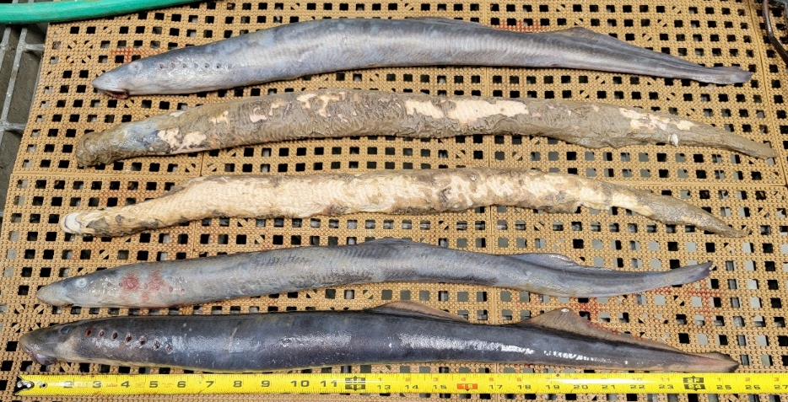
In the afternoon of 03 July, Columbia River Inter-Tribal Fish Commission (CRITFC) Biologists notified Bonneville Project Biologists of one lamprey mortality found on the valve 15 trash rack in the Adult Fish Facility (AFF). The fish was scanned for PIT tags, inspected, and returned to the river.
Photo 1. AM Morts
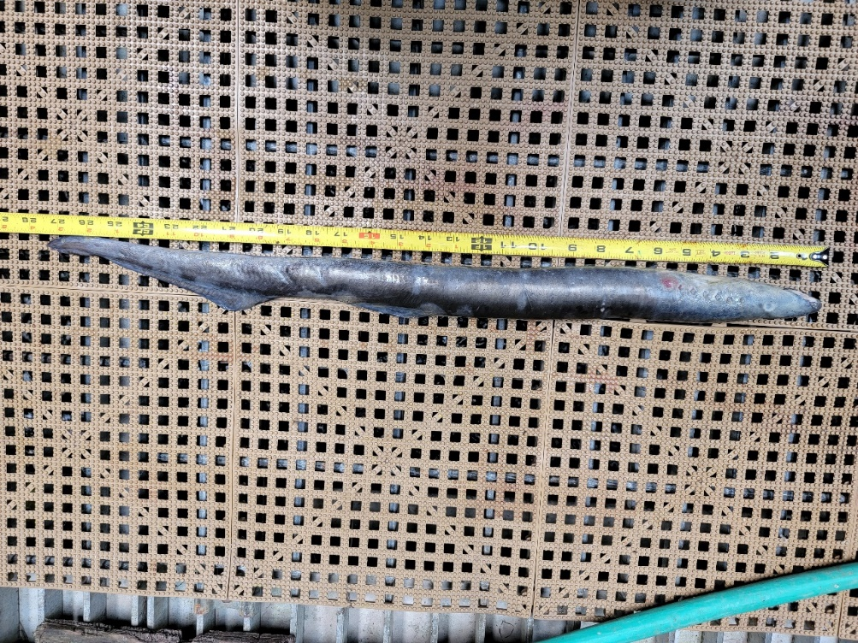
Photo 2. PM mort.

- Species – Pacific Lamprey (Entosphenus tridentatus)
- Origin – Unknown
- Length – AM Morts - in descending order in the picture: 70.1 cm, 72.4 cm, 67.3 cm, 64.2 cm, 65.7 cm. PM Mort – 69.3 cm
- Marks and tags – None
- Marks and Injuries found on carcass – None
- Cause and Time of Death – Unknown
- Future and Preventative Measures – None
Sincerely,
Project Fisheries

